|  |  |  |
| --- | --- | --- |
| SCHOOL OF INFORMATION AND TECHNOLOGY | | |
| NAME: | DATE PERFORMED: | /50 |
| Section: | DATE SUBMITTED: |

# SYSADM1 – Capacity Management & Planning

## Part 1. A Simulated Dataset for Capacity Planning Exercise

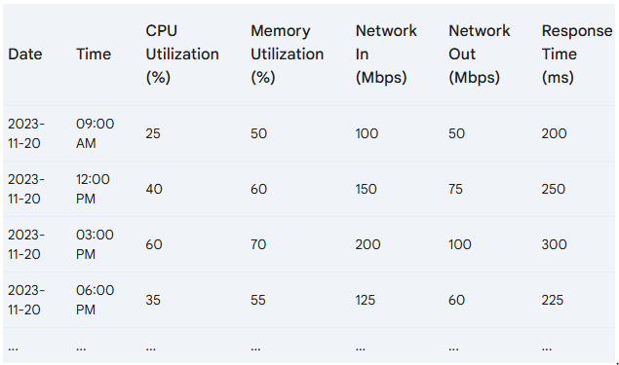**Scenario:** A mid-sized e-commerce website is expecting a significant surge in traffic due to an upcoming holiday sale.

### Projected Traffic Increase

* **Expected Peak Traffic:** 5x the normal peak traffic
* **Peak Time:** 12:00 PM - 3:00 PM on the sale day

### System Specifications

* **Server Count:** 5
* **CPU Cores per Server:** 8
* **RAM per Server:** 32GB
* **Network Bandwidth per Server:** 1Gbps

### Additional Considerations

* **New Product Launch:** A highly anticipated product will be released during the sale.
* **Marketing Campaign:** A major marketing campaign will be launched to promote the sale.
* **Potential Cyber Threats:** Increased traffic can attract malicious actors.

Tasks:

1. Review the provided server performance data and identify potential bottlenecks
2. Brainstorm possible solutions to address the identified bottlenecks. Propose potential solutions considering hardware and software-based solutions.
3. Discuss the pros and cons of each proposed solution by filling out the table below.

|  |  |  |  |  |  |  |
| --- | --- | --- | --- | --- | --- | --- |
| Proposed Solution | |  |  | | --- | --- | | Pros | Cons | | Cost | Complexity | Potential impact on system performance |

Grading Rubric:

|  |  |  |  |
| --- | --- | --- | --- |
| Criteria | Excellent | 10pts | Good | 7pts | Needs Improvement | 4pts |
| **Problem Identification** | Accurately identifies the primary problem and provides a detailed explanation. | Identifies the main problem and provides a basic explanation. | Identifies a problem but lacks clarity or accuracy. |
| **Solution Proposal** | Proposes multiple relevant solutions and provides detailed explanations, including potential drawbacks and benefits. | Proposes one or two relevant solutions but lacks detailed explanation. | Proposes a solution but lacks feasibility or relevance. |
| **Evaluation of Solutions** | Provides a thorough evaluation of the proposed solutions, considering factors like cost, complexity, and potential impact. | Provides a basic evaluation of the proposed solutions, but lacks depth. | Does not evaluate the proposed solutions or provides a superficial evaluation. |
| Score: | | | /30 |

**Part 2. Network Scalability Analysis**

Recall the e-commerce website scenario we discussed earlier. Given the expected surge in traffic, analyze the provided network topology diagram. Identify potential bottlenecks and areas where scalability might be a concern. Propose specific strategies to improve the network's scalability and performance to ensure a seamless user experience during the peak traffic period. Consider factors such as increased user demand, new applications, and security threats.



|  |  |  |  |
| --- | --- | --- | --- |
| Criteria | Excellent | 10pts | Good | 7pts | Needs Improvement | 4pts |
| **Network Analysis** | Accurately identifies potential bottlenecks, security risks, and capacity limitations. | Identifies key network components and some potential bottlenecks. | Identifies some basic network components but lacks a comprehensive analysis. |
| **Scalability Planning** | Proposes multiple relevant solutions and provides detailed explanations, including potential drawbacks and benefits. | Proposes some relevant scalability strategies but lacks detail. | Proposes limited scalability strategies. |
| **Evaluation of Solutions** | Proposes comprehensive scalability strategies, including specific recommendations for hardware upgrades, software configurations, and network optimizations. | Provides a basic evaluation of the proposed solutions, but lacks depth. | Does not evaluate the proposed solutions or provides a superficial evaluation. |
| **Proposed Design** | Provides a detailed and well-justified design, including network diagrams, configuration details, and implementation plans. | Provides a basic design but lacks specific details and justifications. | Does not provide a clear and detailed design. |
| **Evaluation and Justification** | Provides a thorough evaluation of the proposed solutions, considering factors like cost, complexity, and potential impact. | Provides a basic evaluation of the proposed solutions, but lacks depth. | Does not evaluate the proposed solutions or provides a superficial evaluation |
| Score: | | | /50 |